Pectoralis major, Anterior Joint Capsule
Because the fibres of this muscle lie in different directions, it is best to hit it from different angles.
- Stand in a doorway with shoulders and elbows at 90 degrees, hands clasping the door frame to stretch the horizontal fibres and those originating from the clavicle
- Take a step in through the door and hold this
- Raise your hands further up the door frame to hit the lower sternal fibres and that part of the muscle that originates lower on the chest
Hold this position for the appropriate time
Pectoralis Minor
- Lie on your back with knees bent.
- Keep your arms comfortable at your sides .
- Actively pull your shoulder blades together and feel your shoulders flatten toward the floor.
- Try and pull your shoulder blades down toward your feet as well.
- Hold this.
- Bring your elbows out from your sides and let your hands fall back with your elbows at 90 degrees.
- Again, pull your shoulder blades down and back to bring your shoulders closer toward the floor.
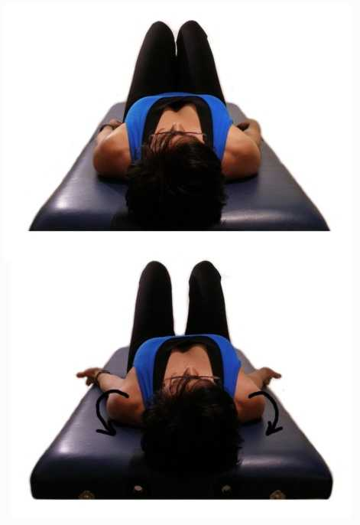
- Hold this stretch for the appropriate time.

PECTORALIS STRETCHING GUIDE

