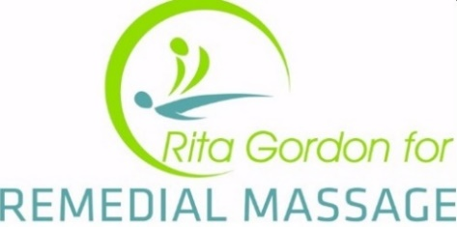

What is Gua Sha and Cupping

Gua Sha: This traditional Chinese treatment literally translates to English as “scraping bruises”. Essentially, Gua Sha is when the practitioner places a Gua Sha specific oil on the skin and then uses the edge of a Chinese soup spoon to gently scrape the skin in order to produce a light bruising. This bruising will not occur if the tissue is healthy. Generally, it is used on the neck and back area where over-tight tissues reside. The action of Gua Sha scraping builds up fluid, and then creates a vacuum behind it. This in turn allows the muscle to expel toxic and stagnant blood from deep within the injury to the skin’s surface, which appears as red, purple, or green blotches, depending on the age of the toxins. Following this, fresh blood is able to flow to the muscle, enabling it to accelerate regeneration of the muscle.

Cupping: Another technique used in traditional Chinese Medicine, to aid in the relief and curing of certain health conditions. The name “cupping” comes from the cups (glass or bamboo) that create suction on the skin to promote the flow of energy (Qi) and blood in the body. It is often used to treat muscle and joint pain, spasms, and problems with internal organs.

Side Effects

Gua Sha and Cupping:
- Red marks
- Swelling
- Bruising
Please note that these side effects will occur and usually last approximately 3-4 days.

