HOW TO IMPOROVE JAW PAIN

- SOFT DIET – Avoid all hard, tough foods that require prolonged or excessive chewing e.g. No hard crusts of bread, tough meat, raw vegetables or nuts. Avoid biting hard or brittle foods with the front teeth. You must cut up food into small pieces, do not open your mouth wide and chew slowly on your back teeth using small slow chewing strokes.
- AVOID PAINFUL JAW USE – if something hurts, DON’T DO IT! On the other hand try using your jaw as much as you can without causing pain
- MOIST HEAT AND MASSAGE (wheat bag, hot water bottle/towel) – Apply heat to both sides of the face for 3 minutes – four times a day. Massage anti-inflammatory gel into the sore area for 2 minutes.
- HABIT CONTROL – No chewing gum/fingernails or chin sitting. Do not sleep with pressure on your jaw. Avoid sleeping on your stomach.
- “N” POSITION: TEETH APART - LIPS SLIGHTLY TOGETHER – Place the tip of your tongue up against the roof of your mouth or behind the ridge of palate just behind your upper front teeth. Say “N”. The teeth should be slightly apart. (Figure 1) Repeat six (6) times then keeping the teeth apart you can relax your lips lightly together. This is the correct jaw postural position.
- HINGE AXIS OPENING – for a few days this should be repeated six (6) times per day. – With the tongue in the “N” position, commence smoothly and rhythmically opening and closing the jaw. The jaw should open straight down but no more than 15mm. The jaw should neither deviate to one side or forward. The teeth should not touch. Open and close jaw six (6) times. Place you index fingers against your TJMs to monitor that they are only rotating and not translating forward. (Figure 2).
- MEDICATIONS – as prescribed.
- ACTIVE STRETCH – 3 Steps
- As directed apply resistance to hinge axis jaw opening from the “N” position for six seconds then relax. Repeat 3 times.
- With the tongue held in the “N” position, use your thumb and forefinger (as directed) to gently Stretch your jaw as wide as possible without causing pain. As you open, you can slide the tongue back. Relax for a moment the repeat the stretch.
(To reduce pain during the stretches, you can sweep an ice block over the area as shown in figure 3)
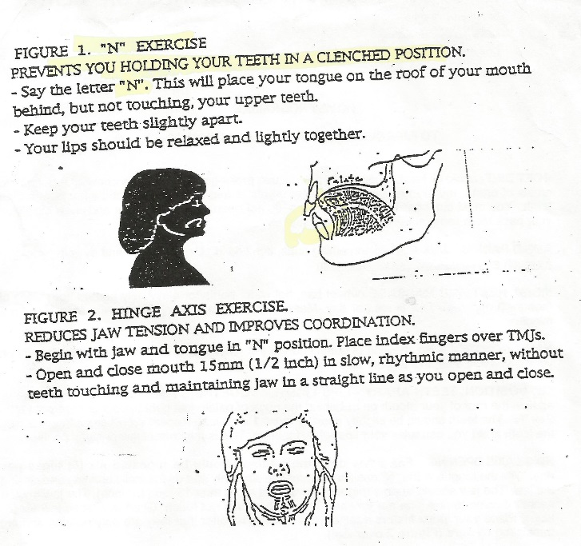
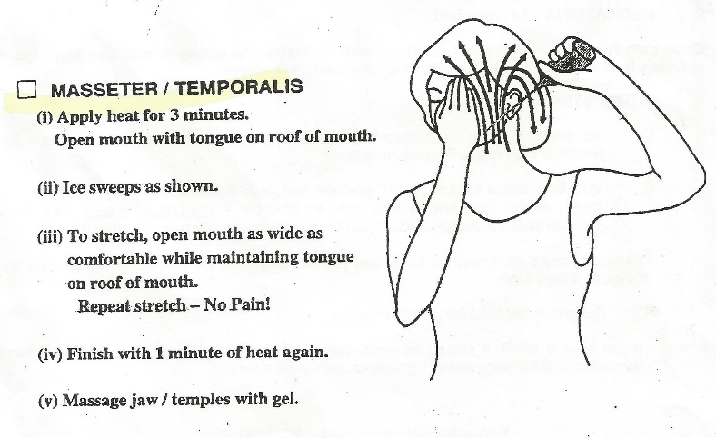
- Reapply moist heat for two (2) Minutes.
Figure 3

