Hip Stretches

It is common to develop muscle imbalances around the hip. Hip stretches are part of a treatment plan to address these. In people that sit at work for long periods of time hip flexors and rotators can become tight, and gluteal muscles become weak. This can affect gait, posture, spinal stability, and movement patterns.
Approximately 15 degrees of hip extension is required to walk normally. If hip flexors are tight then in order to walk, compensatory movement needs to take place through the lower back causing back pain and premature disc degeneration. Like other joints, if we fail to take them through their full range on a regular basis we eventually lose mobility.

Hip Stretches Contents
What are the Major Muscles of the Hip?
Why do We do Hip Stretches?
What is Piriformis Syndrome?
The Significance of Tight Hip Flexors in the Elderly
Hip Stretches

Muscles of the Hip  Because the line of muscle action varies relative to the axis of rotation of the joint some muscles will have more than one action depending on the position of the hip.  Hip Flexors  - Psoas Major and Minor  - Iliacus  Hip Extensors  - Semimembranosus  - Semitendinosus  - Bicep Femoris  - Gluteus Maximus  Hip Abductors  - Gluteus Medius  - Gluteus Minimus  - Tensor Fascia Lata  Hip Adductors  - Adductor Brevis  - Adductor Longus  - Adductor Magnus  - Pectineus  - Gracilis  Hip Rotators  - Piriformis  - Obturator Internus and Externus  - Superior and Inferior Gemelli  - Quadatratus Femoris | 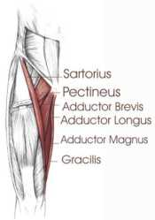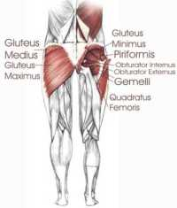

Why do We do Hip Stretches?
The hip is a very stable ball and socket type joint with an inherently large range of motion. The hip contains some of the largest muscle in the body as well as some of the smallest. Most people lack mobility due to a relatively sedentary lifestyle. Periods of prolonged sitting results in tightness of the hip flexors and hamstrings. Tightness in the muscles and ligaments can created joint forces that result in arthritis, postural problems, bursitis, and mechanical back pain.
Positioning of the hip affects pelvic and spinal posture and function so the regular performance of hip stretches will help you maintain a good posture and alignment.

What is Piriformis Syndrome?
The piriformis originates over the anterolateral surface of the sacrum where it lies close the the sacral nerves S2-S4. It then inserts into the greater trochanter along with the other powerful external hip rotators.
The syndrome consists of the symptoms that result from mechanical impingement or irritation of the sciatic nerve as it emerges from the pelvis. This can be pain, tingling, burning, or numbness that worsens with movement of the hip into adduction, internal rotation, and flexion.
Physical therapy is used to treat piriformis syndrome through freeing up the nerve, increasing mobility, relaxing muscle tone, and increasing the resting length of the piriformis muscle. Hip stretches are one part of a treatment plan.
If you experience some of these symptoms you should consult a physical therapist to rule out other sources of radiating leg pain.

The Significance of Tight Hip Flexors in the Elderly
Gait analysis studies in the elderly show that they typically have a shortened step length. Whether that is a result of tight hip flexors or due to reduced balance, the propensity to walk with shorter steps will itself lead to tightness in hip flexors and anterior joint structures. Hip stretches may be a relatively easy preventative strategy for the elderly with gait abnormalities and may help to prevent falls.
The only activity performed on a regular basis that fully extends the hip is walking and running. Hence as activity levels decrease so does the ability to extend the hip. This results in compensatory pelvic tilting and lumbar extension, with a reduction in the ability to accommodate uneven ground, negotiate obstacles, or attempt to change walking speed quickly. The compensatory pelvic tilt that accompanies tight hip flexors also predisposes the individual to postural problems and back pain. Hip stretches done on a regular basis can help you maintain extension range of motion and thereby improve function.

Hip Stretches
Hip Flexor Stretch  The hip flexors are the psoas major, psoas minor, and iliacus muscles, all of which insert into the lesser trochanter on the femur.  - To stretch the right hip flexors kneel on your right knee and put your left foot in front of you such that your left hip and knee are about 90 degrees.  - Put a cushion on the floor for your knee if you find this uncomfortable.  - Put your right hand on your right hip and push your right hip forward so that it is in front of your right knee.  - Keep your chest up and don't bend forward at the hips. | 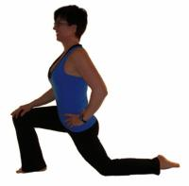
Hip Rotator Stretches  The hip rotators not only rotate the thigh on the pelvis but more functionally rotate the pelvis on the weight bearing fixed thigh. Activities such as swing a golf club, and even just walking require some rotation of the pelvis on the weight bearing leg. While we don't need that much range of motion to walk, activities such as running, dancing, tennis, and many other sports can require more hip rotation.  Internal Rotators  - To stretch the right side in sitting cross your right leg over the left so that your right ankle is laying across your left thigh.  - Put your right hand on your right thigh and gently press down until you feel resistance.  - Then tilt forward at the hips slowly as you exhale. Remember to keep your chest up and your back straight. Don't allow yourself to hunch forward or lose the normal lordosis (inward curvature) in your lower back.  - Hold this position for the appropriate time. For most individuals 30 seconds is beneficial.  External Rotators  - Again, to stretch the right side, begin as above with your right ankle laying across your left thigh.  - Grab hold of the right knee with both hands and pull your right knee up toward your left shoulder.  - Pull to the point of resistance but not pain as you exhale slowly.  - Hold this for the appropriate time.  For a more intense stretch for those of you who are more flexible to begin with you can try these other two hip rotator stretches on the floor:  Floor hip stretch 1  - Sit on the floor with your right knee bent in front of you and your left knee out to the side with left foot behind you. Bring your right foot around such that it touches the left knee.  - Put your hands on the floor in front of you with your arms straight. Inhale and lift your chest up.  - Breath out as you lower your shoulders over your front knee until you feel a gentle stretch.  - Inhale as you raise your chest while maintaining a good curvature in your lower back.  - Lower yourself again forward and repeat this until you can lower yourself to the floor.  - Rest your head on your hands and relax your breathing to allow the stretch to go further.  - When you are exhaling slowly look around toward the back leg and move your hands toward that direction.  This hip stretch addresses multiple muscles and planes. Tightness around the hip joint and hip muscles is very common among athletes and will restrict full movement and optimum performance.  Floor hip stretch 2  This is a stretch for the hip rotators on the right side while lying down.  - Lie on your back with your knees bent and feet flat on the floor.  - Cross your right leg over the left so that your right ankle is across your left knee.  - Keep your head and chest flat on the floor while performing this hip rotator stretch.  - Tighten your abdominal muscles and push your lower back down against the floor and lift your left foot up off the floor.  - As you are lifting your left foot, hold onto your right ankle with your left hand and gently push your right knee down away from you.  - Hold this position for the appropriate period of time, relax, and breath.  You need a certain amount of trunk control and abdominal strength to do this exercise. If you find it too difficult because of weakness or lower back discomfort then try the hip rotator stretch in sitting.  People with arthritis in their hips will have a lot of difficulty with this stretch. If you experience pain down the front of your thigh or groin pain then seek the advice of a physical therapist. You may have a hip joint dysfunction or other problem that may worsen if not treated appropriately. | 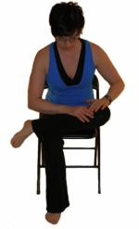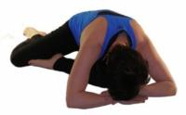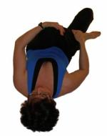
Hip Adductor Stretches  The adductors are those muscles situated on the inside of your thighs. Some cross both the hip joint and the knee joint, and some cross only the hip joint. We will refer to those muscles that cross both the hip and the knee joint as the long adductors and those that cross only the hip joint as the short adductors.  Short Adductors  - Kneel onto your right knee and put your left foot in front of you such that your left knee is at 90 degrees.  - Inhale and slide your right knee out to the side and back.  - Exhale and left your chest up.  Long Adductors  - Kneel onto your left leg and place your right foot in front of you to assume the lunge position.  - Slide your right foot out to the side and place both hands on the floor in front of you.  - Try to straighten the right knee and lean your body forward while relaxing your hips.  - Rocking the hips forward and back will change the pull slightly to get all muscles.  Long adductors can also be stretched in sitting. This hip stretch also includes hamstrings biasing the medial hamstrings, semimembranosus and semitendinosus.  - To stretch both sides simultaneously sit with your legs straight out in front of you with your back straight.  - Slowly work your legs apart as far as they will go. Hold this and relax for a few seconds.  - Now as you exhale bend forward at your hips until you feel more resistance.  - Be sure to keep your chest up and maintain a lumbar lordosis (normal inward curvature of the lower back)  - Hold this for the appropriate time. Most people will gain a benefit from 30 seconds. | 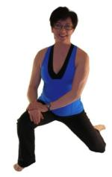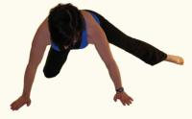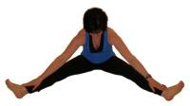
Hip Extensor Stretches  The powerful hip extensors, the hamstrings and gluteus maximus can be stretched as follows. Most of us rarely need to stretch the gluteus maximus as this muscle is often kept in a lengthened position all day as we sit; however, as we sit the hamstrings are kept in a shortened position so often the hamstrings will become tight.  Here are a couple of easier hamstring stretches. For more detailed hamstring stretching see the following page on Hamstring Stretches.  The standing hamstring stretch is valid as an effective method of increasing hamstring flexibility, but depends on pelvic positioning. If you are able to maintain a straight lower back while performing this stretch it is significantly more effective.  - To perform this stretch stand and face a chair or table. Keep your chest up and back straight.  - Bend forward at the hips until you feel a stretch in the back of your thigh.  - Most people will benefit from a 30 second hold.  The hamstring stretch through the doorway has also been validated in the literature, and is easier in terms of maintaining a stable pelvis.  - This stretch is performed by lying on the floor with one leg on the wall and the other flat on the floor through the doorway.  - Pull yourself closer to the wall as you feel a stretch.  - Most people benefit from this stretch being held 30 seconds.  This hamstring stretching method has been shown to be just as effective as the standing hamstring stretch. | 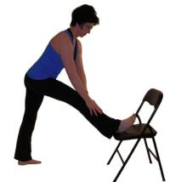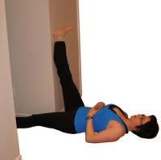
Iliotibial Band Stretches  The iliotibial band is a thickening of the fascia lata, the deep fascia of the thigh. Think of it as a thick long ligament like structure that connects the hip to the lower leg along the outside of the thigh. Tightness in the iliotibial band can cause patellofemoral pain, trochanteric bursitis, and friction syndromes at the knee. This is a hip stretch I commonly prescribe to runners and people suffering from knee pain.  To stretch the right iliotibial band stand with your right side facing a wall or chair.  - Put your right foot behind your left foot and point the toes of your right foot out about 45 degrees.  - Put your left hand on your left hip and while keeping your right leg straight, push your hip in toward the wall.  - A common mistake made when performing this stretch is to bend forward at the hips or to rotate the body.  - Make sure you remain upright and keep your torso perpendicular to the wall.  For more detailed hip stretches for the iliotibial band see my page on the iliotibial-band. | 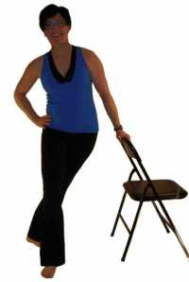

Share this page:
What's This?
- Home

The Science
- How to Stretch
- How Long
- Improve Stretching
- Breathing & Stretching
- Muscle Physiology
- Stop Stretching?
- Contraindications
- Precautions

Type of Stretching
- Static Stretching
- Dynamic Stretching
- Ballistic Stretching
- Passive Stretches
- PNF Stretching
- Fascia Stretches
- Foam Roller
- Bad Stretching

The Stretches
- Back Stretches
- Hip Stretches
- Neck Stretches
- Iliotibial Band - A common source of hip and/or knee pain
- Quadriceps Stretches
- Shoulder Stretches
- Adductor Stretches
- Calf Stretches
- Bruegger Exercise
- Forearm Stretches
- Hamstring Stretches
- Knee Stretching

Sports
- Running
- Swimming
- Golfing Stretches
- Ice Hockey Exercises

Posture
- What is Posture
- How to Improve Posture
- Exercises for Posture

Other Populations
- Exercises for Seniors

Conditions
- Groin Injury
- Hamstring Tightness
- Myofascial Pain
- Stretching Pain
- Hamstring injuries
- Hamstring Injury Prevention

.
- About Me
- Disclaimer
- Privacy Policy

