Strengthen your Posterior and Anterior Neck Muscles
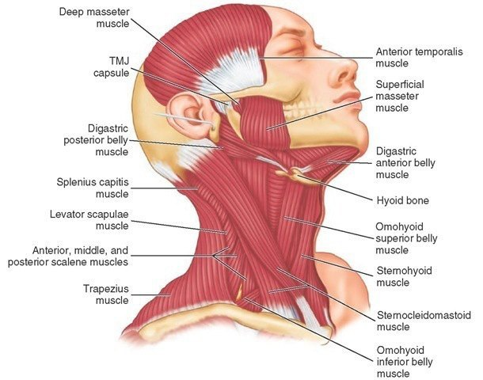

The posterior and anterior neck muscles support the neck and cervical vertebral foramen (these can also be described as the holes in the neck bones) to contain the spinal cord. The spinal cord is one of the most important items in our body – if it is damaged, it may leave you paralysed from the neck down.
Step 1 – Sitting Neck Exercise

Whilst sitting down, move your neck forward, backward, side to side, twist, and diagonally. Tense your neck muscles to ensure that you are strengthening rather than just stretching. Do this twice a week.
Step 2 – Anterior Neck Exercise

Now lie on your back on your bed without a pillow. Dip your chin slightly to your chest to lengthen your posterior muscles. Lift your head slightly off the bed and hold for 20 seconds. Rest for a minute and repeat 2 more times. Now lift and twist your head from side to side at least 15 times. You can also do this with your head over the edge of your bed and in line with your body.
Step 3 – Posterior Neck Exercise

Find a comfy chair to sit in. Clasp your fingers behind your head and lean your head gently back into your clasped hands. Hold for ten seconds. Rest for 30 seconds and then repeat 2 more times.

Find further info at http://www.wikihow.com/Strengthen-Posterior-Neck-Muscles

