Lower Back Pain

Lower back pain is common amongst most individuals, and can interfere with every day activities. There are several factors that cause lower back pain, here listed are only a few that can cause lower back pain; tight hip flexors, tight QL, tight hamstrings, improper lifting, poor posture, weak glutes and weak abdominal muscles. Luckily here are some stretches and strengthening exercises to help you strengthen or loosen these muscles.

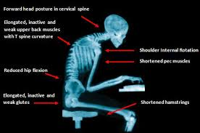

Hip Flexors
To loosen hip flexors there are several variations of the stretch that can be completed. For the best result stretches should be held for 1-2 minutes.

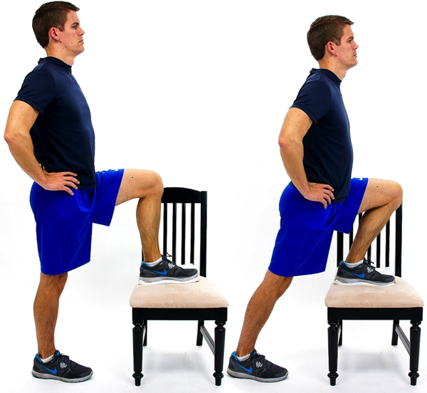
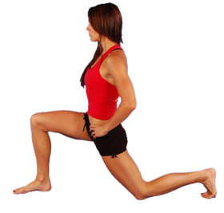

Tight QL (lower back muscles)
Stretches: these should be held for 30 seconds to 1 minute, making sure you slowly ease in to the stretch.

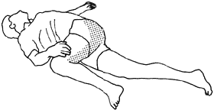

Focuses on stretching out the muscles responsible for rotation and lateral flexion. Be sure t do both sides.

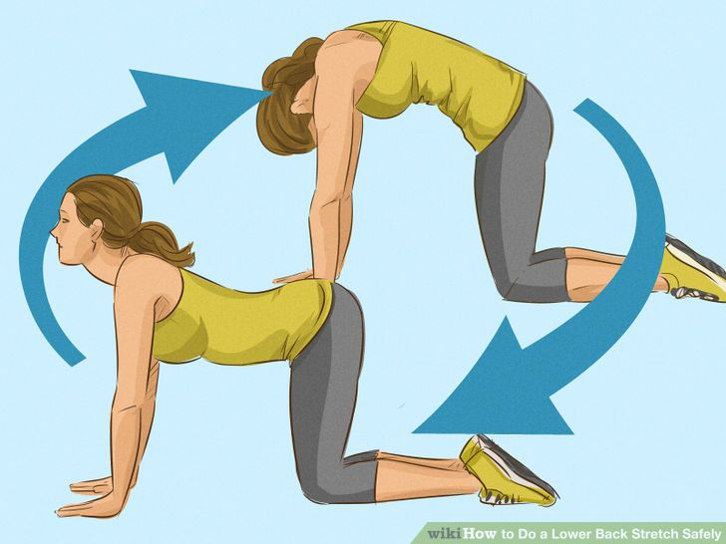

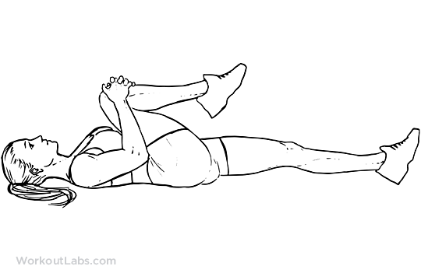

Tight hamstrings

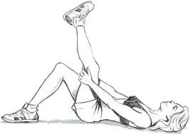
Hamstring stretch

Improper lifting
To ensure the proper lifting technique is used ensure back is kept straight while lifting.

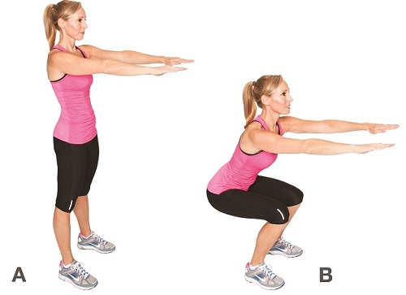
Squat

Weak glutes and abdominals
Glutes and abdominals can be trained by doing pelvic tilts and back bridges as seen below. Start with pelvic tilts which utlises contraction of the glutes (butt muscles) and abdominal mucles to tilt the pelvis, while carrying out this movement be sure to try to draw the belly button to the ground. Progression of this exercise is the back bridge which focuese on stregnthing the glutes. Do 3 sets of 10.

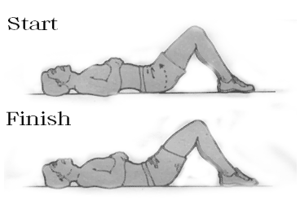
Pelvic tilt
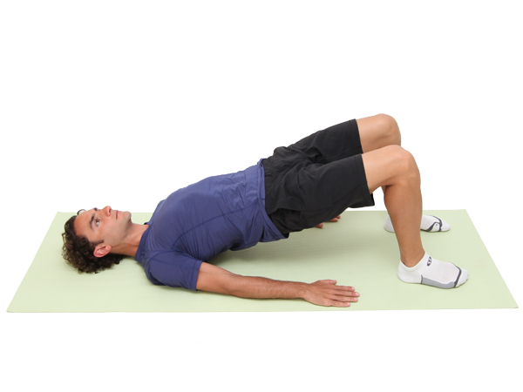
Back bridge
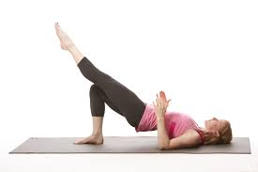
Back bridge progression

