Stretching suggestions

Hip flexor/psoas stretching
Reverse lunge with overhead reach
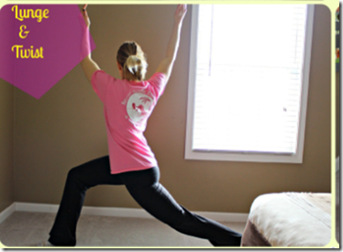

Strengthening suggestions

Glute Bridge
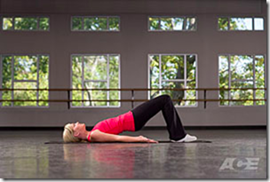
Lie supine on the floor in a bent-knee position with your feet flat on the floor. Engage the abdominals by pushing the lower back into the floor, and maintain this throughout the exercise. Push your hips up off the floor by pressing your heels into the floor. Avoid hyperextension by pushing up your hips too high.

http://www.yourtrainerpaige.com/2013/08/fire-up-your-glutes/

